TFS #92342

Add FEMA Hyperlink for flood maps on Buildings Panel

Overview

Add FEMA hyperlink to the Buildings Panel in Collateral Web for Farm Credit East, AgCountry, and Yankee.

April Beston

09/30/2016

Table of Contents

TFS # 1

Description 2

Testing Notes 2

Screen Shots and Steps Taken 2

# Description

BCM 8/5/16 - Original Request: "In LOS there was a hyperlink that took us to the FEMA determination site. This does not show anywhere in Collateral Web. Is there any way to include this link again? It should go on the building tab."

Notes: Used to live on collateral screen in EmPOWER desktop, go into buildings details (see [link](https://central.financialpartners.com/Depts/ProdServices/empwebpatch/FPIDocuments/2016%20Q4%20Collateral%20Web%20Enhancements/Requirements/Flood%20Map%20Hyperlink.msg) for screen shot). Probably go on the Buildings Panel in the Smart Data Wizard for Real Estate.

RJM 8/5/16 - DEV NOTE - We should source the link from AssociationParameters.SearchFloodMapsURL.

See Development Notes tab.

 RJM 8/8/2016 - This was item #34 from the Collateral Web Enhancements list.

BCM 9/6/16 - Hyperlinks should be set up as following:

FCEast: <http://www.interflood.com/>

AgCountry: [https://lender.floodapp.com](https://lender.floodapp.com/)

Yankee: <http://www.interflood.com/>

FCWest: None

Northwest: None

# Testing Notes

TEST - FEMA Hyperlink for flood maps on Buildings Panel

Hyperlinks should be set up as following:

FCEast: <http://www.interflood.com/>

AgCountry: [https://lender.floodapp.com](https://lender.floodapp.com/)

Yankee: <http://www.interflood.com/>

FCWest: None

Northwest: None

AMB 09/30/16: Test Passed – Verified that FEMA link was present and brought user to the correct website for FCE, AgCountry, and YKE. Verified that link was present when adding new collateral or editing existing collateral. Also, verified that link is not present in FCW or Northwest.

## Screen Shots and Steps Taken

Navigate to Buildings screen in the Real Estate SDW. (Note: this screen is called “Buildings & Improvements” in AgCountry). When editing an existing piece of collateral, the SDW is opened by hovering over the piece of collateral, choosing the edit icon, then choosing edit details. When adding a new piece of collateral, the SDW automatically comes up once the collateral is dragged into a scenario –

To enter SDW from an existing piece of collateral –

Hover over collateral and choose the edit icon:

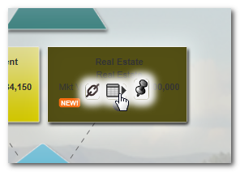

Choose “Edit Details”:

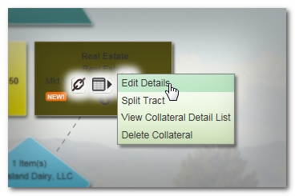

Once in the SDW, navigate to the Buildings screen. Then click on “Search Flood Maps” (Note: “The property includes buildings or improvements” must be checked for the Buildings screen to be available):

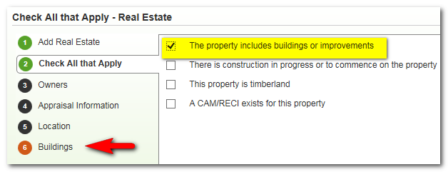

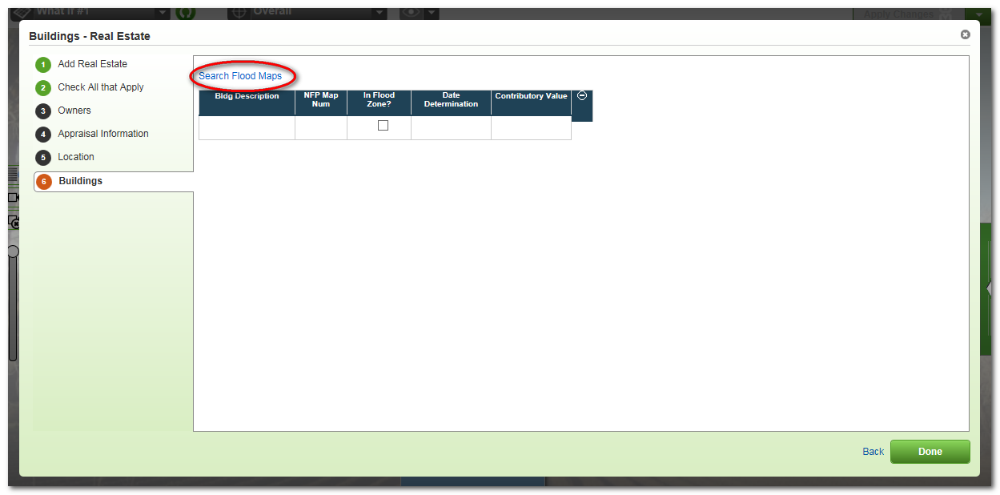

Clicking on this link will bring up the association specific Flood Map search website –

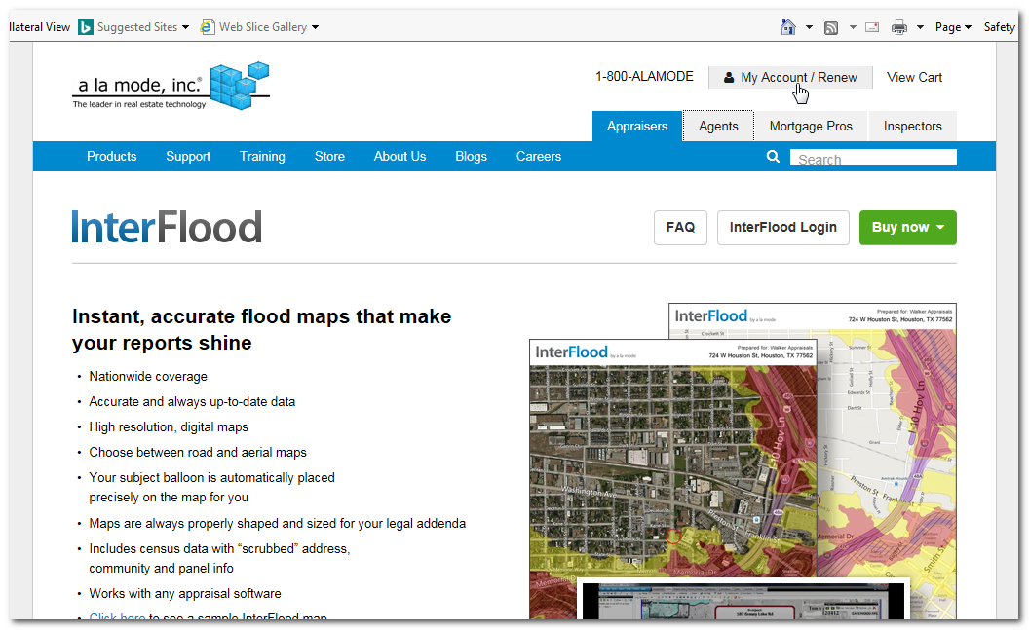

I also negative tested to ensure this link was not available in FCW and Northwest, this test also passed.